Fathers Network
Poker & Pizza Night

Put on your Poker face…

This is a chance for Dad’s to:
- Get out of the house
- Hang out with the guys
- Eat pizza and have some fun!

Thursday, Dec 10th
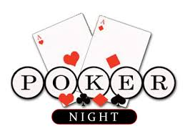
5:00 pm
(Pizza and conversation
Poker games begin at 6)

Held at the Arc office
2500 Hewitt Ave Suite 300
Everett, WA 98201
(425) 258-2459

No experience or money needed!
There will be prizes, snacks and refreshments

Please RSVP to FathersNetwork@arcsno.org
or contact Jamie Coonts at 425-258-2459 ext. 104

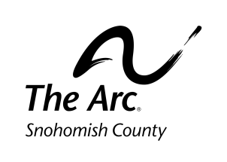
Everyone is welcome to show up even without contacting us, but we would love to know if you are coming so we know how much food to order.
www.arcsno.org

