Dads Connecting With Dads: Dynamic!

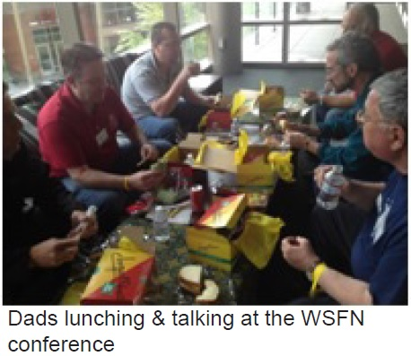
By Greg Schell
Director, Fathers Network, Kindering
When dads take the time to connect with other dads having children with special needs, and/or chronic health conditions, the results are rather incredible. The University of Washington-Bothell conducted research regarding Washington State Fathers Network (WSFN) in late 2012, substantiating some very positive and powerful affects on fathers, their children and families. This was very encouraging information, but not totally unexpected.
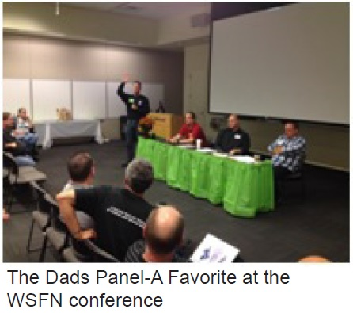
Two previous research projects results also demonstrated outstanding data. One of the projects included looking specifically at Latino and Native dads in very rural areas, and African American dads from the inner city. It appears dads find connections with other dads very useful regardless of differences.
What did the latest research show? The cross-sectional design study had 146 members voluntarily and confidentially reply to 38 survey questions. The researchers uncovered some very useful data:
- Anxiety decreased 97 percent
- Enthusiasm toward their child increased 69 percent
- Family relationships improved 77 percent
- Feelings of joy increased 67 percent
- Having someone to relate to increased 80 percent
- Feelings of hopelessness decreased 57 percent
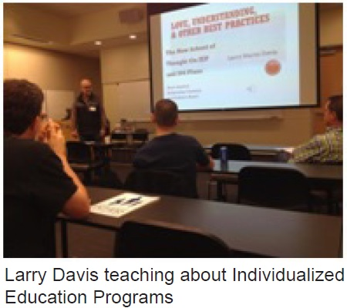
A lot of research confirms stress levels in families having children with special needs is often much higher than in typical families. It also appears from the research noted above some very positive things happen to dads, their children, and their families when dads connect. When dads proclaim they have increased enthusiasm for their children, improved family relationships, and their feelings of joy increase significantly when connecting with other dads, it seems easy to theorize this connection is valuable for everyone in the family. Maybe even to the point of decreasing overall stress.

Each October WSFN gathers dads from around the state and a few from beyond the borders to a conference only for dads. Many dads shared their perspectives of the Oct. 11, 2014 conference on their evaluations. This is what they had to say:
"I didn't come with any expectations. However, it exceeded anything I could have possibly imagined."
"This was my first time at a WSFN event. I cannot express how much it means to me. It was very insightful and helpful."
"I feel renewed."
"I recommit to being a better dad to my sons and a better husband to my wife."
"The sense of community and camaraderie was amazing. I felt a wonderful sense of support and understanding."
"Superb in all ways. Great (dads) panel and workshops."
The evidence is clear. Get dads together and great things happen! Do it!

AMCHP
Association of Maternal & Child Health Programs, PULSE Newsletter November-December 2014

